Git-HOL Exercise-1:
Step-1:
Check Git Version:
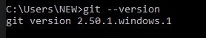
Configure User Name and mail:
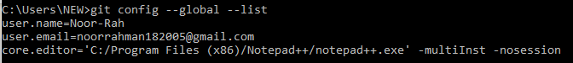
Create GitDemo and Perform First Commit by pushing Welcome.txt:
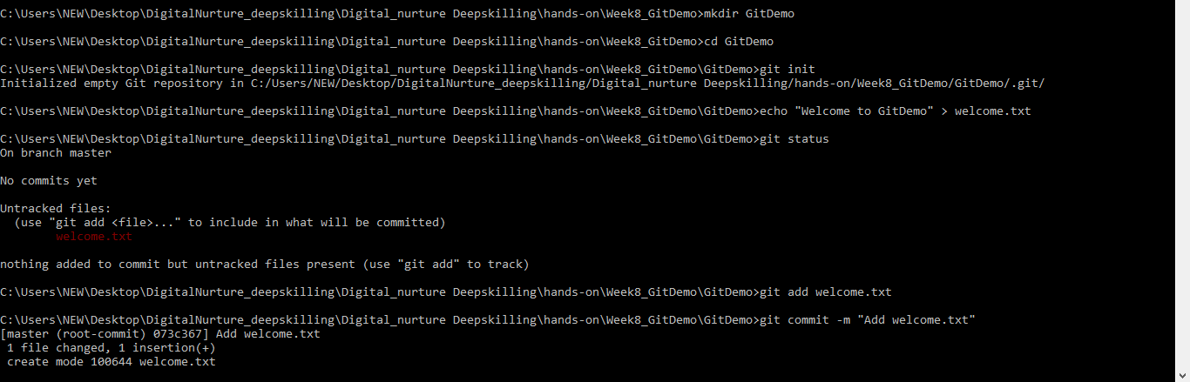
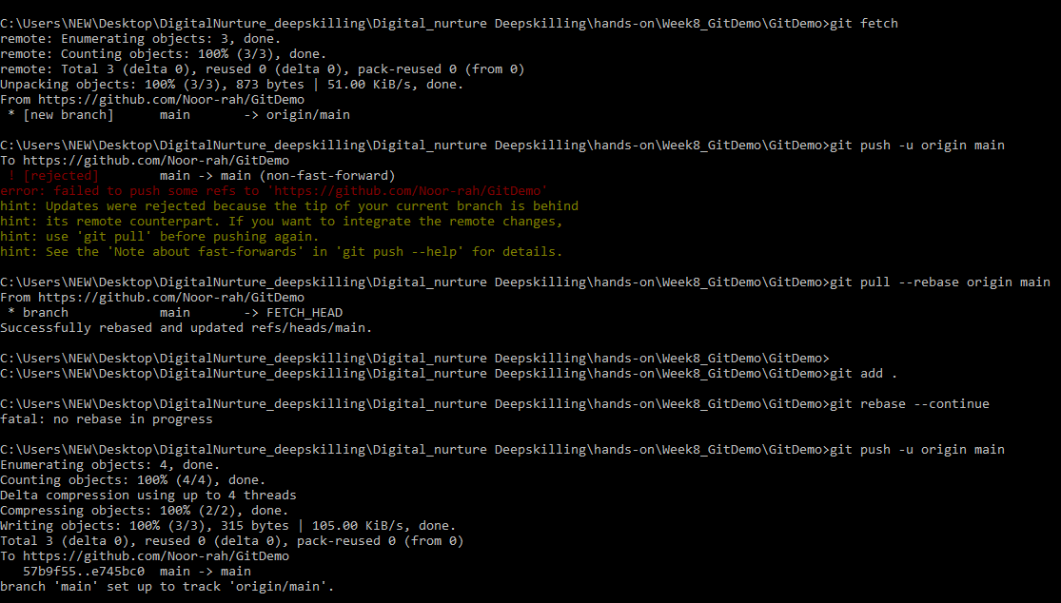

OUTPUT:
